Newsletter
Issue 24

15 March 2024

Dear Parents and Carers

Science Week
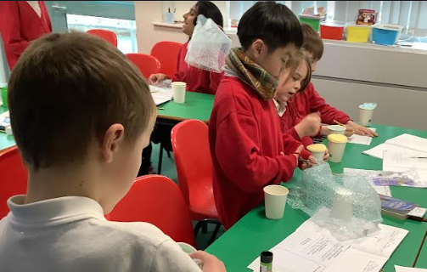
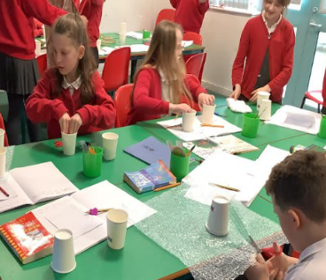
This week we have been celebrating British Science Week and the theme for this year was TIME. We started the week with an active assembly involving a time test experiment, and then, during the week the children have engaged with a variety of activities around the theme of time. We all had great fun experimenting, exploring and investigating.

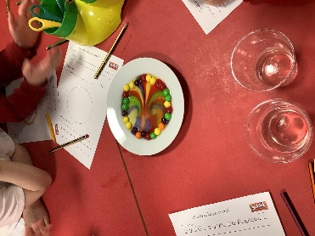
Year 4 have been making ear defenders with paper cups and bubble wrap – they enjoyed the science of making them and seeing how they worked.

Year 1 have carried out a skittles experiment and created amazing rainbow patterns as the sugar dissolved when we added warm water.

Year 1 also visited Winchester Science Centre and really enjoyed making and testing their own rockets! They had great fun exploring the interactive resources and watching a show about planets in The Planetarium.

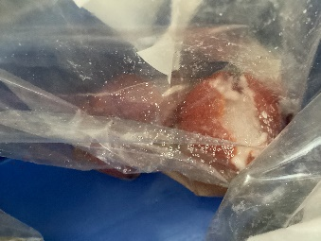
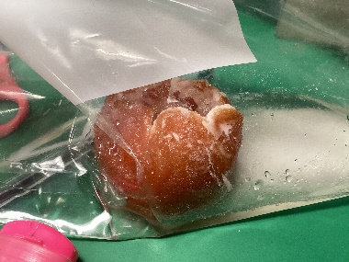
Year 5 are studying the mummification process of a tomato which we are watching over TIME to see what happens. We are logging data within a table.

Roadworks
Please note that SGN will be continuing with roadworks in connection with essential gas supply upgrades from this coming Monday, 18 March and these works will take some weeks. The disruption will be around Compton Way, Oliver’s Battery Crescent and Austen Avenue and will involve traffic lights amongst other things. The company apologises in advance for any inconvenience and promises to keep disruption to a minimum and be as quick as they can!
Football Team
Our school football teams have had another very successful week! Following on from our Boys A Team's success last week, our Boys B Team played Otterbourne Primary School on Wednesday and won 5-1 which was our first win of the season! It was a keenly contested game and it was much closer than the final scoreline suggested. Zac scored three goals, Cyrus scored one and an own goal completed the scoring for our team.

Yesterday, our Girls Team also picked up their first point of the season with a 2-2 draw away at St Peters School. Ava scored a great goal for our team to put us ahead in the second half, after an own goal had put us ahead in the first half. St Peters responded twice to equalise and a draw was probably a fair result overall. This game was played in a great spirit and atmosphere between the players and spectators alike and it was a really positive experience for everyone involved.

Change of Menu
There will be a change of menu on the last day of term Thursday 28 March. The red choice will be Fish and Chips and the green choice will be Cheese and Tomato Quesadilla followed by an Easter Biscuit.

Winchester Cathedral
The Cathedral have some lovely activities for children planned for the Easter holidays. Please follow the links to find out more https://www.winchester-cathedral.org.uk/event/easter-workshops/ Plus, new for 2024 - Children’s Urban Safari https://www.winchester-cathedral.org.uk/event/childrens-urban-safari/

Integr8 Easter Holiday Workshops
Integr8 are very excited to have received funding from HCC again this Easter and are able to offer free places on their holiday camps for children in receipt of free school meals. All eligible children will receive a hot meal per day and children can be booked onto as many days as they require.

The camps are taking place 2 – 12 April and will be held at either Unit 12, Winnall Valley Road, Winchester or Winnall Primary School.

For more information please email info@integr8dance.com.

Kings’ School Summer Fair
Save the Date! Kings’ School Fair will be held on Saturday 8 June this year. More details to follow.

The Big Plastic Count
A reminder to bring back to school on Monday your tally sheets from the The Big Plastic Count thank you.

After School Club
Further to our recent Parentmail email, please be reminded that there will be NO After School Club this coming Tuesday, 19 March.
Listen to Me Concerts
The end of term Listen to Me Concerts for Years 2 and 4 will be taking place on Thursday 21 March. Year 2 will be at 2pm and Year 4 at 2.30pm. Due to shortage of space in the hall we are only able to offer this to parents/carers of Year 2 and 4.

Breakfast Club
For safeguarding purposes please can you ensure that you sign your child/ren in if they are attending Breakfast Club and not let them walk down alone.

Quiz Night
Save the date! The PTA are planning on holding a quiz night for adults on Friday 10 May. Get your team together for a fun night of quizzing, bar, nibbles and prizes.

Learning Behaviours
We have held this week’s Learning Behaviours assembly. This is where a teacher chooses a child/children that has demonstrated the chosen learning behaviour of the week. The teacher shares with everyone what the child has done and then we all celebrate their achievement. This term we are looking at resilience. The children who were chosen this week were:

Year One Matilda L
Year Two Mila C
Year Three Orla S
Year Four Ella D
Year Five Millie W
Year Six Saar D

Lunchtime/Playtime Leaders

The children who were chosen this week were:
Frankie W - Ladybirds
Ema A - Bumblebees
Daisy H - Hares
Nefeli Z - Hares

Science and Engineering Day
To celebrate British Science Week Southampton University is running a science festival which involves more than a hundred interactive activities, workshops, live shows, art performances and Lab tours at the Highfield Campus and Boldrewood Innovation Campus in Southampton. This is taking place on Saturday 16 March.

For more information and to book your free place go to the Southampton and Science and Engineering Festival website.
Spanish Club
Please find attached a flyer regarding the Spanish Club which runs on a Tuesday lunchtime here at school. They have currently got spaces for KS2 children after Easter.

Football Club
We are happy to announce that we are able to offer this club to girls and boys in Years 3 and 4 after the Easter holidays. They will be running on Wednesdays after school and will run from Wednesday 17 April through to Wednesday 22 May. The cost will be £48 for the half term. For more information and to sign up please go to: bookwhen.com/mattwellsfootballcoaching.

School Lunches
Thank you to everyone for settling their lunch accounts, however the lunch debts are still high - please could you ensure that your account is kept up to date. For your information the money owed per class is as follows:-
Hares £ 187.73
Foxes £ 87.40
Herons £ 148.45
Kingfishers £ 250.30
Nursery £ 34.00

Please could we ask that your child does not order a school lunch if the debt is above £10.00 and to provide them in a packed lunch. Please can you arrange to clear your Lunch accounts as soon as possible.

If you would like an up to date statement of your child’s account please contact the Admin Team. If you have not yet registered to pay online via Scopay and would like a copy of your login details please email us and we will be happy to help. We would appreciate it if all accounts, including any outstanding Breakfast Club and After School Club accounts, could be settled as soon as possible. Please ensure that your After School Club Account is up to date as we employ extra staff for this club. If you would like an up to date statement please contact the school office.

Thank you for your continued support.

Yours faithfully

Mrs Bordoli
Interim Headteacher

Dates for your diary (new dates in red)

Ferny Crofts Residential Trip Meeting (Year 5) 3.40 20 March 2024
Listen to Me Concerts 2pm Year 2 and 2.30pm Year 4 21 March 2024
Rocksteady Concert (2.30pm) 25 March 2024
School Choir 3pm 27 March 2024
Herons Egyptian Dress up day (Year 5 only) 28 March 2024
School breaks up for Easter 28 March 2024
School returns 15 April 2024
Year 5 trip to Ferny Crofts 24 - 26 April 2024
Inset Day 28 June 2024
Inset Day 1 July 2024
School breaks up for summer 23 July 2024

